Ex.No. 1

Date:

DDL Commands – CREATE, ALTER, DROP

Aim:

To Create, Alter and Drop the table using Data Definition Language.

Description:

Data Definition Language (DDL) statements are used to define the database structure or schema.

DDL Commands: Create, Alter, Drop, Rename, Truncate
• CREATE - to create objects in the database
  - ALTER - alters the structure of the database
- • DROP - delete objects from the database

  - TRUNCATE - remove all records from a table, including all spaces allocated for the records are removed
  - RENAME - rename an object

SYNTAX:

CREATE TABLE

CREATE TABLE table_name
(

column_name1 data_type,
column_name2 data_type,

column_name3 data_type,

....
);

ALTER A TABLE

To add a column in a table

ALTER TABLE table_name

ADD column_namedatatype;

To delete a column in a table
ALTER TABLE table_name

DROP COLUMN column_name;
DROP TABLE

DROP TABLE table_name;

TRUNCATE TABLE

TRUNCATE TABLE table_name;

Questions:

1) Create a table name STUDENT with following structure.

 | Column
# | Name | Description | Data Type
 |  | Registration
1 | RegNo | Number | NUMBER(3)
2 | Name | Student Name | VARCHAR(15)
 |  | Gender of the
3 | Gender | student | CHAR(1)
4 | DOB | Date of Birth | DATE
5 | MobileNo | Mobile Number | NUMBER(10)
6 | City | Location of stay | VARCHAR(15)

2) Create a table name FACULTY with following structure.

 | Column
# | Name | Description | Data Type
1 | FacNo | Faculty Identifier | VARCHAR(4)
2 | FacName | Faculty Name | VARCHAR(15)
3 | Gender | Gender of faculty | CHAR(1)
4 | DOB | Date of Birth | DATE
5 | DOJ | Date of Join | DATE
6 | MobileNo | Mobile Number | NUMBER(10)

3) Create a table name DEPARTMENT with following structure.

 | Column
# | Name | Description | Data Type
1 | DeptNo | Department Identifier | VARCHAR(4)
2 | DeptName | Department Name | VARCHAR(15)
3 | DeptHead | Department Head | VARCHAR(4)

4) Create a table name COURSE with following structure.

 | Column
# | Name | Description | Data Type
1 | CourseNo | Course Identifier | VARCHAR(3)
 |  | Course
2 | CourseDesc | Description | VARCHAR(14)
3 | CourseType | Course Type | CHAR(1)
4 | SemNo | Semester Number | CHAR(1)
5 | HallNo | Hall Number | VARCHAR(4)
6 | FacNo | Faculty Identifier | VARCHAR(4)

- Modify the table FACULTY by adding a column name DeptNo of datatype VARCHAR(4)

OUTPUTS:

- 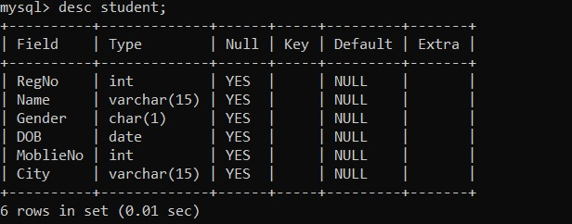

2)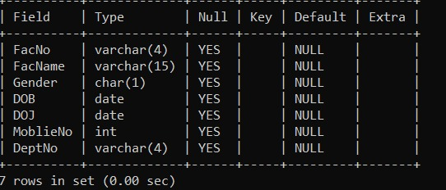

3)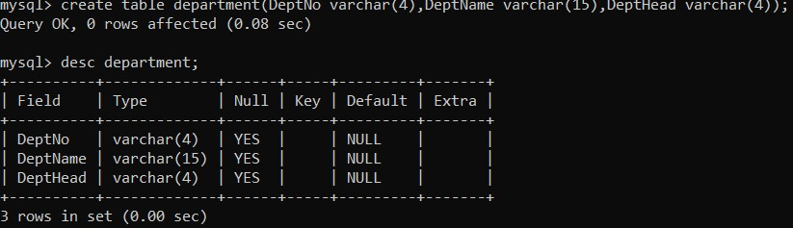

4)

5)
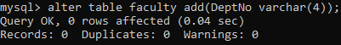

RESULT:
Tables are created, altered and modified using DDL commands.

